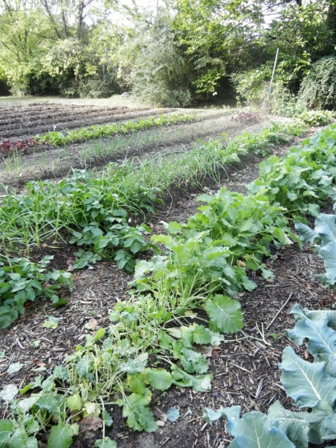

**“Putting Your Garden to Bed”**

**Wednesday, September 4, 2013**

**6:00 to 8:00 p.m.**

**Shirley J. Luck Senior Citizens Center**

**109 East Main Street**

**Johnstown, NY 12095**

**Cost: $5.00 per person payable at on-site registration**

***Interested individuals must pre-register on or before August 28, 2013***

***by calling 518-673-5525***

***Cornell Cooperative Extension Master Gardener Barbara Henry will highlight what you need to do to get your garden ready for the winter.***

• ***Learn what to do with your annuals, summer bulbs and containers as well as your lawns and autumn leaves that cover them.***

• ***Learn how to handle your perennials, how to deal with early frosts in your vegetable gardens, and what steps to take to prepare your garden beds for next year.***

*Cornell Cooperative Extension in Fulton and Montgomery Counties provides equal program and employment opportunities.*